Archers’ Forms

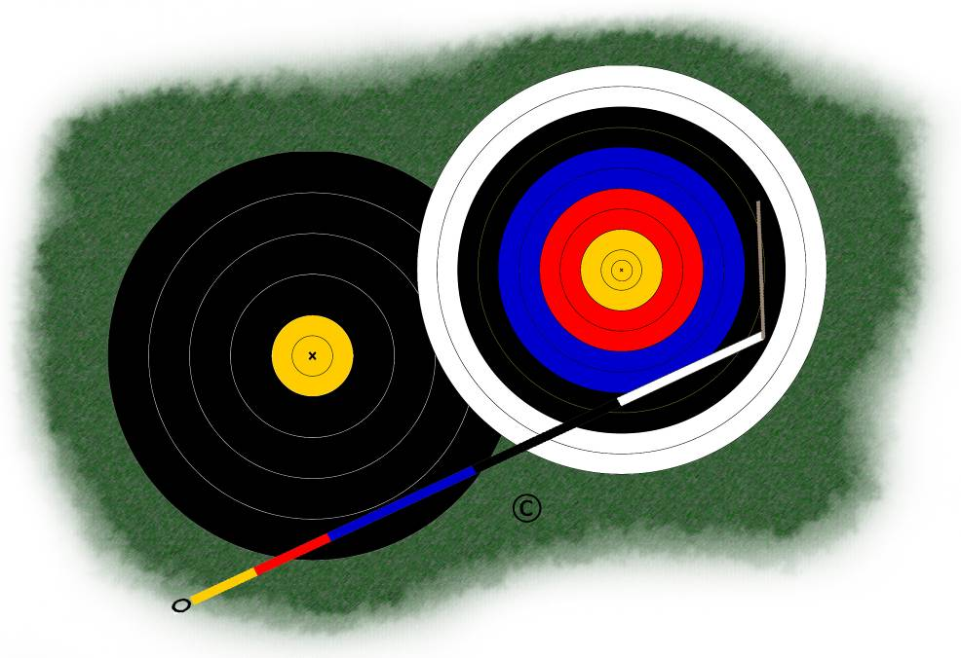

Personal Archery Equipment Details
Recurve Bow

Name:
Club Name:
Date Completed:

Arrows
Arrow Purpose: | Outdoors | Indoors
Shaft:
Manufacturer
Type
Model
Nominal Static Spine
Nock:
Manufacturer
Model
Slot size (reference number or throat width)
Nock Weight (gr.)
Point:
Insert Type
Insert Weight
Point Type
Point Weight (gr.)
Fletches:
Manufacturer
Model
Length (ins.)
Fletch Weight (gr.)
Fletch position (nock slot to back edge) (ins.)
Fletch angle (°)
Completed Arrow:
Cut length (nock slot -> end of shaft) (ins.)
All up length (nock slot to point) (ins.)
Total Weight (gr.)
Balance Point (% FoC)

Tab
Tab:
Manufacturer
Model
Size
Platform position (centre of arrow slot - top of platform) (mm.)
Facing material
Backing material
Number of backing layers
Customisations

Bow
Arrow Purpose: | Outdoors | Indoors
Arrow Speed: (f.p.s.)
Riser:
Manufacturer
Model
Serial number
Length (nominal) (ins.)
Window cut beyond centre (mm.)
Colour
Hand grip
Limbs:
Manufacturer
Model
Serial number
Length (ins.)
Nominal weight (at 28” ATA) (lb.)
Actual weight set (at draw length, 20ºC) (lb.)
Upper limb bolt (turns from bolt thread engagement)
Lower limb bolt (turns from bolt thread engagement)
Brace height (to pressure button centre) (mm.)
Tiller setting (top) (mm.)
Tiller setting (bottom) (mm.)
Tiller (mm.)
String:
Material
Structure
Strands
Additional strands to pack nocking point
Length (twisted, non-loaded) (ins.)
String jig length setting (or untwisted length, if you buy from a retailer)
Nock height (to inside of bottom/top nock locator) (mm.)
Serving material
Pressure Button
Manufacturer
Model
Button ref. (identifying mark, if you use more than one)
Centre shot setting
Spring pressure setting
Clicker:
Manufacturer
Model
Blade position (back edge from button centre) (mm.)
Sight:
Manufacturer
Model
Sight ring
Extension
Distance from arrow axis to centre of eye (mm)
Distance from bow sight to eye (mm)

Stabilisation
Long rod:
Manufacturer
Model
Length (ins.)
Damper
Weights used
V-bar extender:
Manufacturer
Model
Length (ins.)
V-bar holder:
Manufacturer
Model
Horizontal angle (from centre line) (°)
Vertical angle (from line of long rod) (°)
TFC
Twin rods:
Manufacturer
Model
Length (ins.)
Damper
Weights used
Top rod:
Manufacturer
Model
Length (ins.)
Damper
Weights used
Bottom rod:
Manufacturer
Model
Length (ins.)
Damper
Weights used
Balance Weight:
Manufacturer
Model
Length (ins.)
Damper
Weights used

Important Notes: A copy of this form should be kept with your equipment. In case of problems while shooting, this will allow you to quickly check the main adjustments.

Bow limbs may give a different weight at extreme temperatures; bow scales may also give different readings according to ambient temperature. Try and keep to normal room temperature or mild outdoor conditions.
Button checkers of the same model may give different results because of spring variation, but are usually accurate enough to allow checking and basic set-up of a button.
Eye distances are used in sight-mark calculation software to determine the arrow’s exit angle (initial trajectory).

